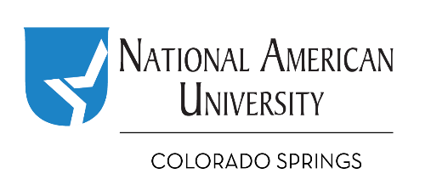

My PLAN for the Future Contest
Prepare for Life, Act Now

Attention Colorado Springs School District 11 Students!

The nonprofit National American University Foundation is pleased to offer the “My PLAN for the Future Contest” to middle school students in Colorado Springs’ School District 11.

This contest challenges middle school students to consider their future goals and develop a plan to support their goals.

The selected student will receive $250. Four students will receive honorable mention and $50 each.

Only students who attend District 11 middle schools (grades 6 through 8) are eligible to apply.

Application requirements for the My PLAN for the Future Contest are --

- A completed application, attached; and

- An essay, no more than 1000 words, typed or handwritten, that addresses –

- Your Goals: Where do you see yourself in 2030? What is the job, industry, career, or other activity that you plan to pursue?; and

- Your Middle School and High School Plan: How do you plan to achieve your goals while in middle and high school? Examples may include, but need not be limited to, the classes you plan to take and any work, volunteer, or leadership experiences you will pursue; and

- Your Post High School Plan: Once you graduate from high school, what must you do next to accomplish your goal? College, military, job, humanitarian work, volunteering, apprenticeship, or other?

Applications and essays will be judged on neatness, grammar and how well the essay addresses your future goals and plans. In addition, we may also consider your –

- Community service;
- Participation in extracurricular activities (at school or out of school);
- Leadership experiences; and/or
- Work or training experiences.

How to Apply
The application and essay, must be received no later than Friday, November 30, 2018. You can apply online, by email, by fax, or by mail to:
Heather Geschke, Campus Director
National American University
Attn: My PLAN for the Future Contest
1079 Space Center Dr., Suite 140
Colorado Springs, CO 80915
naufoundation.org/d11onlineapp
foundation@national.edu
605-721-5241 fax

My PLAN for the Future Contest
Prepare for Life, Act Now

A complete application, including attachments, must be received no later than November 30, 2018,
submitted online to naufoundation.org/d11onlineapp, to foundation@national.edu, by fax to 605-721-5241, or by mail to:
Heather Geschke, Campus Director, NAU, Attn: My Plan for the Future Contest, 1079 Space Center Dr., Ste 140,
Colorado Springs, CO 80915

Applicant's Name: ________________________________________________________________ ____
First Name Last Name M.I.

Mailing Address

Phone Number

Email Address _________________________________________________________________________

Middle School Grade ___________

List here any community service, extracurricular activities (in school or out of school), leadership experiences, work and/or training experiences (you may attach on a separate sheet of paper if necessary):

OPTIONAL (Your response to the following has no bearing on your eligibility to receive an award): Whether or not you are accepted receive this award, may the NAU Foundation, NAU or school district use your name, name of school, and essay solely for university and school district purposes? Your contact information will never be shared.

_____Yes _____ No (If yes, please also include your parent or guardian’s signature below).

Please submit with this application with your essay (see criteria for essay requirements). Both the application and essay must be received no later than November 30, 2018 for the application to be deemed complete and on time.

Student's Signature* Date

For optional media release:

Student’s Parent or Guardian Signature* Date

*Signatures may be typed if submitting by email.

