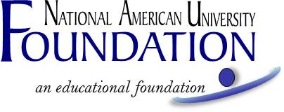

KAITLYN ENGLISH MEMORIAL SCHOLARSHIP
FALL 2019 ACADEMIC TERM
Recipient Selection Criteria

To be eligible for the Kaitlyn English Memorial Scholarship, the student must:

- Be enrolled in NAU’s Clinical Core Nursing Cohort at NAU’s Wichita location; and
- Have a minimum cumulative GPA of at least 2.5.

Five awards are available to five students. Each recipient will receive one of the following awards, determined according to independent, double-blind review rankings: $850, $500, $350, $300, and $250. The awards will be disbursed for the Fall 2019 term, conditioned upon enrollment in the Fall 2019 term.

Students who have received any Kaitlyn English Memorial Scholarship in the past ARE eligible to apply. Total scholarships and funding received from NAU or the NAU Foundation, NAU Employee Education Benefits, federal grants and outside resources must not exceed the total amount due for tuition per course, or the scholarship will be reduced.

If you are utilizing Federal Financial Aid to assist with paying for your tuition, and if you are approved for this scholarship, it could affect the amount of Federal Financial Aid you are eligible to receive. If you have questions about how it will affect your Financial Aid prior to applying, please contact your campus financial services representative.

Application forms will be available on or about July 9, 2019 at naufoundation.org/scholarships or from your advisor.

The application, with all required attachments (see below), must be received no later than July 26, 2019 and are to be submitted online, by email, by fax or by mail as follows:

NAU Foundation
Attn: The Kaitlyn English Memorial Nursing Scholarship
5301 Mt Rushmore Rd
Rapid City, SD 57701
naufoundation.org/nursing
foundation@national.edu
605-721-5241 fax

A complete application includes, and the selection committee will consider, the following:

- Application form, and
- 2 Letters of reference from non-relatives, and
- A brief autobiography, including your reason for why you chose to become a nurse and where you hope the career will take you.

Scholarship recipients may also be selected based on consideration of:

- Financial need.
- Academic achievement.
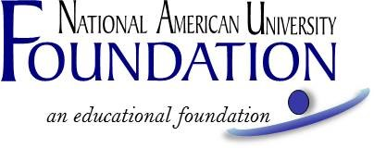
KAITLYN ENGLISH MEMORIAL SCHOLARSHIP
FALL 2019 ACADEMIC TERM
APPLICATION FORM

A complete application, including attachments, must be received no later than July 26, 2019. You can apply online at naufoundation.org/nursing, or submit the following application and essay to foundation@national.edu, by fax to 605-721-5241, or by mail to: NAU Foundation, Attn: Kaitlyn English Memorial Nursing Scholarship, 5301 Mt Rushmore Rd, Rapid City, SD 57701.

Applicant's Name: ______________________________________________________________________
Last Name First Name M.I. (Maiden)
Current Mailing Address

Phone Number ________________________________________________________________________
Email Address _________________________________________________________________________
Expected Graduation Date
Cumulative GPA ____
Have you applied for financial assistance for the upcoming academic year?
Yes ______ No ______ If no, explain.

Are you currently employed? (Part-time/full-time--explain)

Optional. Your response to this question has no bearing on your eligibility or chances to receive a scholarship. Your contact information will never be shared or sold: I consent to allow National American University to use information, photographs, video and other images of me for any purpose, including but not limited to, publicity, promotion, and advertising. I understand and agree that all such material and any reproductions are the property of National American University, which has the right to copyright, duplicate, alter, distribute, and publish them in any manner and in any format. I waive the right to inspect or approve the finished product, including written copy that may be created in connection with such material. I release and agree to hold harmless the university, its officers, agents and employees, and all persons acting under its permission or authority, from any claims and liability in connection with such material. I am at least 18 years of age, have read this consent and release, and fully understand its contents. ____Yes ___ No

Please submit with this application 2 letters of reference from non-relatives (in any form) and a brief autobiography (500 -750 words) that includes your reason for pursuing a nursing degree and where you hope your career will take you.

Student's Signature Date

_____ My picture is attached (Optional; no bearing on scholarship selection).

