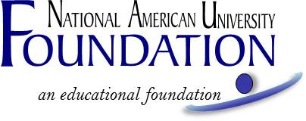

BILL TSCHETTER PARALEGAL STUDIES ACADEMIC EXCELLENCE SCHOLARSHIP
Fall 2019 Academic Term

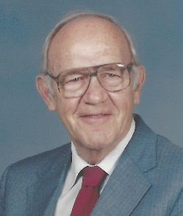
This scholarship is offered in memory of R. William “Bill” Tschetter, who in 1988 started National American University’s Paralegal Studies Program. “Bill was a man of vision,” recalls Paul Sedlacek, NAU’s General Counsel. “The college didn’t start the program. Bill approached the college. A lot of people are slowing down at age 64, not starting something new.” Bill is remembered by former student, Ellen Bishop, as someone who taught his students “soft, funny and serious, but above all, well. He believed in the law, and he wanted us to be a part of a team.” Bill passed away in 1996 but his legacy – the NAU Paralegal Studies program and graduates – remains.

Recipient Selection Criteria

To be eligible for the Paralegal Studies Academic Excellence Scholarship, the student must:

- Be enrolled in NAU’s Paralegal Studies program, and
- Will be attending half-time or more (at least 6 credits) at NAU for the Fall 2019 academic term, and
- Have a minimum cumulative GPA of 3.5, evaluated at the end of the most recent term.

One award is available to one student in the amount of $500. The award will be disbursed for the Fall term, conditioned upon enrollment in the Fall term.

Past recipients of THIS scholarship are not eligible. Total scholarships and funding received from NAU or the NAU Foundation, NAU Employee Education Benefits, federal grants and outside resources must not exceed the total amount due for tuition per course, or the scholarship will be reduced.

If you are utilizing Federal Financial Aid to assist with paying for your tuition, and if you are approved for this scholarship, it could affect the amount of Federal Financial Aid you are eligible to receive. If you have questions about how it will affect your Financial Aid prior to applying, please contact your financial services representative.

Application forms will be available on or about July 7, 2019 at naufoundation.org/scholarships.

A complete application includes, and the selection committee will consider, the following:

- Application form, and
- A brief autobiography, including your reason for why you chose to pursue a paralegal studies degree, and where you hope the career will take you.

Other considerations may include:

- Academic achievement at National American University.
- Financial need.

The application and required essay must be received no later than July 26, 2019 and may be submitted online, by email, by fax or by mail to:
NAU Foundation
Attn: Paralegal Scholarship
5301 Mt Rushmore Rd
Rapid City, SD 57701
naufoundation.org/paralegalapplyonline
foundation@national.edu
605-721-5241 fax
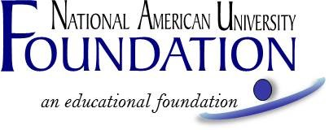
BILL TSCHETTER PARALEGAL STUDIES ACADEMIC EXCELLENCE SCHOLARSHIP
FALL 2019 ACADEMIC TERM
APPLICATION FORM

A complete application, including attachments, must be received no later than July 26, 2019. You can apply online at naufoundation.org/paralegalapplyonline, or submit the following application and essay to foundation@national.edu, by fax to 605-721-5241,
or by mail to: NAU Foundation, Attn: Paralegal Scholarship, 5301 Mt Rushmore Rd, Rapid City, SD 57701

Applicant's Name: ______________________________________________________________________
Last Name First Name M.I. (Maiden)
Current Mailing Address

Phone Number ________________________________________________________________________
Email Address _________________________________________________________________________
Campus ______________________________________________________________________________
Expected Graduation Date
Cumulative GPA ____
Have you applied for financial assistance (including but not limited to employee tuition assistance, military discount, etc.) for the upcoming academic year?
Yes ______ No ______ If no, explain.
Are you currently employed? (Part-time/full-time--explain)

Optional. Your response to this question has no bearing on your eligibility or chances to receive a scholarship. Your contact information will never be shared or sold: I consent to allow National American University to use information, photographs, video and other images of me for any purpose, including but not limited to, publicity, promotion, and advertising. I understand and agree that all such material and any reproductions are the property of National American University, which has the right to copyright, duplicate, alter, distribute, and publish them in any manner and in any format. I waive the right to inspect or approve the finished product, including written copy that may be created in connection with such material. I release and agree to hold harmless the university, its officers, agents and employees, and all persons acting under its permission or authority, from any claims and liability in connection with such material. I am at least 18 years of age, have read this consent and release, and fully understand its contents. ____Yes ___ No

Please attach and submit with this application a brief autobiography (250 words or less) including your reason for why you chose to pursue a paralegal studies degree, and where you hope the career will take you.

Student's Signature Date

_____ My picture is attached (Optional. Has no bearing on scholarship selection).

