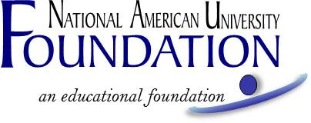

AVERA HEALTH SURGICAL TECHNOLOGY STUDENT SCHOLARSHIP
Fall 2018 Academic Term

Recipient Selection Criteria

To be eligible for the Avera Health Surgical Technology Student Scholarship, the student must:

- Be enrolled at least half-time in NAU’s Associate of Applied Science in Surgical Technology program at NAU’s Sioux Fall Campus.

One award is available to one student in the amount of $2,000. The award will be disbursed $667 per quarter for three consecutive quarters of the succeeding academic year beginning Fall 2018. The scholarship recipient must be attending at least half-time in NAU’s Associate of Applied Science in Surgical Technology program at NAU’s Sioux Fall Campus to receive the disbursement. For the second and third payments, the student recipient must also be achieving at least a 3.0 cumulative grade point average and not have a financial hold on his/her account.

Students who have received other scholarships are still eligible to apply for this scholarship. Total scholarships and funding received from NAU or the NAU Foundation, NAU Employee Education Benefits, federal grants and outside resources must not exceed the total amount due for tuition per course, or the scholarship will be reduced.

If you are utilizing Federal Financial Aid to assist with paying for your tuition, and if you are approved for this scholarship, it could affect the amount of Federal Financial Aid you are eligible to receive. If you have questions about how it will affect your Financial Aid prior to applying, please contact your campus financial services representative.

Application forms will be available on or about July 9, 2018 at naufoundation.org/scholarships, on the student portal under My Documents, or from your advisor.

The application, with all required attachments (see below), must be received no later than September 3, 2018 and are to be submitted by email to foundation@national.edu; or by fax to 605-721-5241; or by mail to:
NAU Foundation
Attn: Avera Health Surgical Technology Student Scholarship
5301 Mt Rushmore Rd
Rapid City, SD 57701
A complete application includes:

- Application form, and
- One (1) letter of reference from a non-relative, and
- A brief autobiography (500 words or less), including why you chose to become a surgical technician and where you hope the career will take you.

In addition to application materials, scholarship recipients may also be selected based on consideration of financial need.
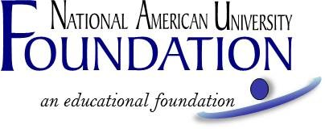

AVERA HEALTH SURGICAL TECHNOLOGY STUDENT SCHOLARSHIP
Fall 2018 Academic Term

APPLICATION FORM

A complete application, including attachments, must be received no later than September 3, 2018, submitted to
foundation@national.edu; or 605-721-5241 fax; or by mail to:
NAU Foundation, Attn: Avera Health Surgical Technology Student Scholarship, 5301 Mt Rushmore Rd, Rapid City, SD 57701

Applicant's Name: ______________________________________________________________________
Last Name First Name M.I. (Maiden)
Current Mailing Address

Phone Number ________________________________________________________________________
Email Address _________________________________________________________________________
Start Date at NAU Expected Graduation Date
Have you applied for financial assistance for the 2018-2019 academic year?
Yes ______ No ______ If no, explain.

Are you currently employed? (Part-time/full-time--explain)

Optional: “My Reason”: In one word or one brief sentence, what is your reason for going to college?

_____________________________________________________________________________________________

With this application, please also provide one letter of reference from a non-relative and brief autobiography (less than 500 words), including why you chose to become a surgical technician and where you hope the career will take you.

If you are accepted to receive a scholarship, may we use your name, campus, expected graduation date and degree in NAU publications? _____Yes _____ No (If yes, please also return the attached Media Release with your application materials. This is optional and has no bearing on one’s eligibility to receive a scholarship).

Student's Signature Date

Optional. Has no bearing on one's eligibility to receive a scholarship.

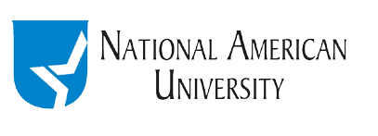

Media Release Form

Name____________________________________________________________________________
Program of Study _________________________________________________________________ Campus__________________________________________________________________________
Email ___________________________________________________________________________

I consent to allow National American University to use information, photographs, video and other images of me for any purpose, including but not limited to, publicity, promotion, and advertising. I understand and agree that all such material and any reproductions are the property of National American University, which has the right to copyright, duplicate, alter, distribute, and publish them in any manner and in any format. I waive the right to inspect or approve the finished product, including written copy that may be created in connection with such material. I release and agree to hold harmless the university, its officers, agents and employees, and all persons acting under its permission or authority, from any claims and liability in connection with such material. I am at least 18 years of age, have read this consent and release, and fully understand its contents.

Signature _____________________________________________ Date ______________

______ Picture is attached (optional)

